Owner(s): |  | Lot #:
Address: |  | Phone #:
Start Date: |  | Completion Date:
Application For:
Please provide a complete, detailed description of this alteration. Please attach to this application a drawing(s), which clearly show the location of the alteration on a copy of the site plan (plat) of the property. Section 2(b).
I understand and agree that no construction or exterior alteration shall commence until written approval of the Architectural Control Committee has been received by me, and that if alterations are made, I may be required to return the property to its former condition at my own expense if this application is disapproved wholly, or in part, and that I may be required to pay all legal expenses incurred. Section 2(g).
No verbal approvals or statements are authorized. Section 2(g).
I understand that an Architectural Control Committee decision is required on all applications within ten (10) business days after the documents have been received, unless the committee requests additional documentation. Section 2(f).
ARCHITECTURAL CONTROL COMMITTEE ACTION:
 | Approved |  | Disapproved
NOTE: A quorum of the committee members is required in order to process this application. Please list each ACC member present during this review in the spaces below: If disapproved, list any comments and/or stipulations:
Signed: |  | Date:
Signed: |  | Date:
Signed: |  | Date:
Signed |  | Date:
Signed |  | Date:

Comments:

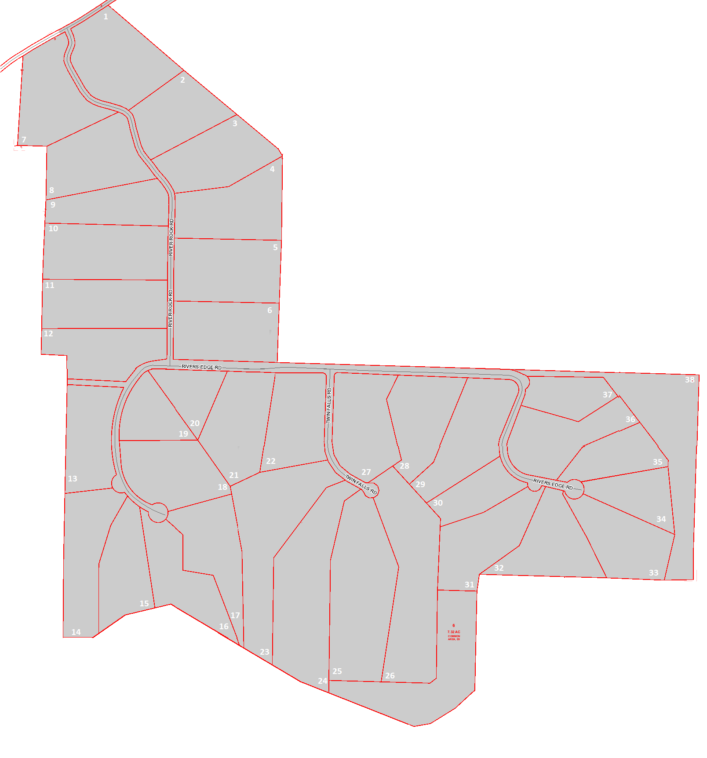

The following is an excerpt of the Bluffs HOA Architectural Committee Statements as found in the Covenants, Conditions, and Restrictions. Due to the likelihood of transposition errors, this excerpt is not guaranteed to be accurate. Any issues which occur will need to be referred back to a true copy of the CCRs.
Article IX
Building Restrictions
Section 1
- There will be architectural controls through an architectural control Committee. Some diversity of architectural design will be encouraged, including European old country, Georgian, federal, antebellum, and American country.
- The electricity and telephone wires and cables will all be underground and the streets and roads will be built to Christian County specifications, and will be surfaced with asphalt.
- The Bluffs will be a gated community with an electronic ingress/egress
- The architectural control committee (“Committee”) will initially consist of three (3) members, a representative of the Developer, a representative of Carol Jones Realtors and an Owner selected by the Developer. After ten (10) Parcels are sold and the building plans approved, the architectural control committee will be expanded to five (5) members consisting of a representative of the Developer, a representative of Carol Jones Realtors and three (3) Owner selected by a majority vote of the then members of the BHOA. The architectural control committee shall review and approve or reject all building plans by Owners of the Parcels for all items set forth in the section. Decisions of the architectural control committee may be appealed to the Board of Directors of the BHOA.
Section 2
The following restrictions are required by this Declaration:
- The minimum ground floor level of any residence on a Parcel shall be not less than 2,400 square feet for a single level home, and not less than 1,600 square feet for a multi-level home. A residence with a walkout basement shall not be considered a multi-level home within the meaning of this Section. The total enclosed square footage of any residence on a Parcel shall be not less than 2,400 square feet, excluding garages and porches.
- No residence, fence, wall, driveway, gate, driveway, cut or design, additions or other structure of any kind may be erected, placed, or altered (including alterations in exterior design) on any parcel until the construction plans and specifications showing the nature, shape, height, materials, and color of the improvement, and a plat showing the location of the improvement on the Parcel, shall have been approved by either the Committee or the Board of Directors of the BHOA.
- In reviewing said documents, the Committee shall consider:
- The quality and design of the improvements, including the nature and durability of materials and workmanship;
- Choice of colors
- The effect of the proposed structure, addition or alteration on the use, enjoyment and value of other neighboring properties and/or the outlook or view from adjacent or neighboring properties; and
- The suitability of the proposed structure, addition or alteration taking into account the general aesthetic values of the surrounding area.
- The minimum side setback is seventy-five (75) feet, rear setback for lots with adjacent back yard boundaries is seventy-five (75) feet and the front setback is a minimum of one hundred (100) feet. The placement of buildings will be encouraged to be consistent with adjacent construction.
- Fences, walls and gates are permitted and encouraged. Fencing and walls should be constructed of natural materials, wood or stone, when possible, but PVC fencing is not prohibited. Chain link fencing is discouraged unless for containment and then only full hidden from view.
- The approval or disapproval as required in this Declaration shall be in writing and shall be issued within ten (10) business days after the documents have been received, unless the Committee request additional documentation. If additional documentation is requested, the ten (10) business day period shall run from the date on which the requested documentation is received. All approved plans shall be dated and initialed by the Developer as authorized by the Committee. If the Committee fails to issue a written approval or disapproval within the time permitted by this Section, the improvement shall be deemed approved. All disapprovals shall state the reasons for disapproval.
- Construction on a Parcel prior to approval in writing is strictly prohibited and may be removed by the Developer or the BHOA at the Owner of the Parcel’s cost. No verbal approvals or statements are authorized and any such statements will not be binding on the Developer or BHOA.
- No Owner of a Parcel shall clear-cut more than fifty (50) feet from the residence or any other structure on the Lot without prior written permission from the Committee.
- Construction on all Parcels shall commence within five (5) years of the initial Parcel purchase and shall e completed and occupied within one (1) year of the commencement of construction. If construction does not commence within five (5) years of the initial Parcel purchase, Developer shall have the right to repurchase the Lot at the initial purchase price paid by the Owner plus six percent (6%) interest, or require the Owner to list the Parcel with a licensed Realtor. Owner of multiple adjoining Parcels being used as a single estate shall not be subject to the provisions of this Section. The purpose of this provision is to encourage Owners to being construction of residences on the Parcels in a timely fashion after the purchase of a Parcel. These time limitations may be waived by the BHOA upon good cause shown.
- All structures other than residences, including garages, barns, and outbuildings, should be constructed of materials consistent with the subdivision guidelines set forth herein and shall match the residence on the Parcel in color and materials. Metal buildings and pre-build storage buildings are prohibited. The setback requirement for any such structure shall be at least seventy-five (75) feet from all roads and property lines on the Property.
- No Parcel, regardless of size, may be subdivided by any Owner without a two-thirds (2/3) vote of all members of the BHOA.

